LAB # 13
Introduction to GitHub
OBJECTIVE:
Introduction to GitHub by creating Git repository and cloning its configuration to eclipse project
Lab Task:
1. Create account on GitHub.
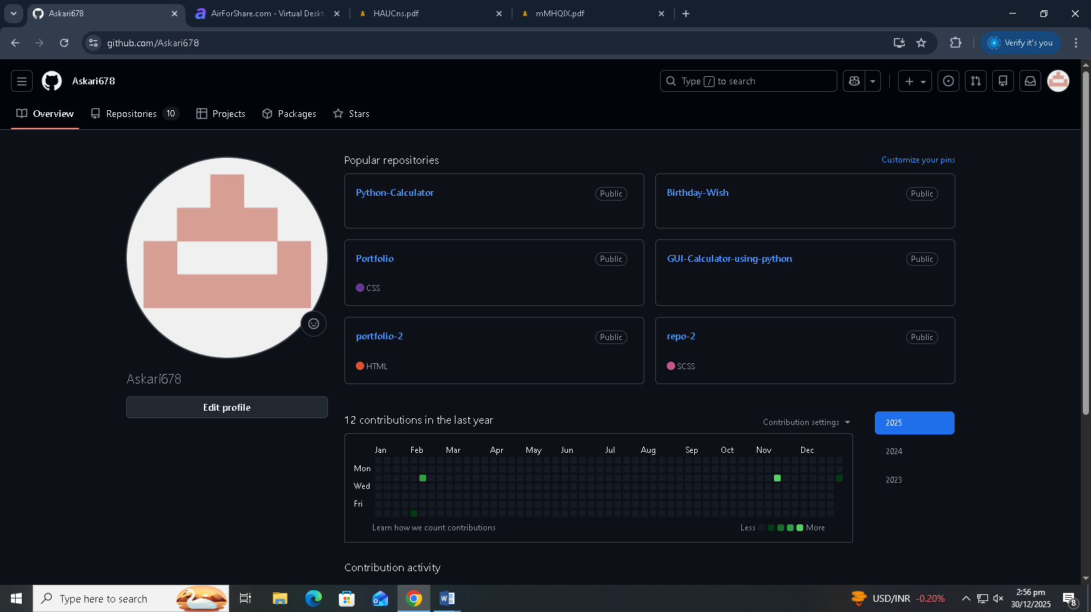

2. Upload any of your Java Project files and perform commit, push, pull and merge operations.

